10

Modelling for computer vision

Computer vision tasks are among the most popular problems in practical applications of machine learning – it was the gateway into deep learning for many Kagglers, including yours truly. Over the last few years there has been tremendous progress in the field and new SOTA libraries continue being released. In this chapter we will give an overview of the most popular competition types in computer vision:

* Image classification
* Object detection
* Image segmentation

We begin with a short section about image augmentation: a group of task-agnostic techniques, that can be applied for different problems to increase the generalization capability of our models.

# Augmentation strategies

While deep learning techniques have been extremely successful in computer vision tasks like image recognition, segmentation or object detection, the underlying algorithms are typically extremely data intensive: they require large amounts of data to avoid overfitting. However, not all domains of interest satisfy that requirement – which is where data augmentations come in. This is a name for a group of image processing techniques that create modified versions of images, thus enhancing the size and quality of training datasets, leading to better performance of deep learning models. The augmented data will typically represent a more comprehensive set of possible data points, thus minimizing the distance between the training and validation set, as well as any future testing sets.

In this section, we will review some of the more common augmentation techniques, along with choices for their software implementations. The most frequently used transformations include:

* Flipping: flipping the image (along the horizontal or vertical axis)
* Rotation: rotating the image by a given angle (clockwise or anticlockwise)
* Cropping: a random subsection of the image is selected
* Brightness: modify the brightness of the image

Scaling: image is increased to higher (outward) or lower (inward) size.

Below, we demonstrate how those transformations work in practice using the image of an American acting legend – comedian Betty White:

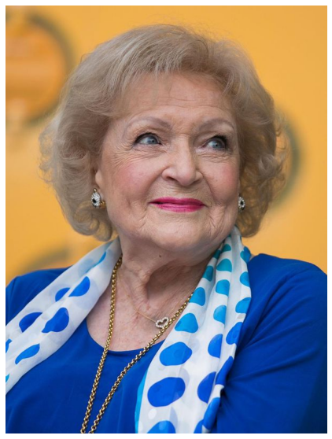

Figure 10.1: Betty White image

We can flip the image along the vertical axis:

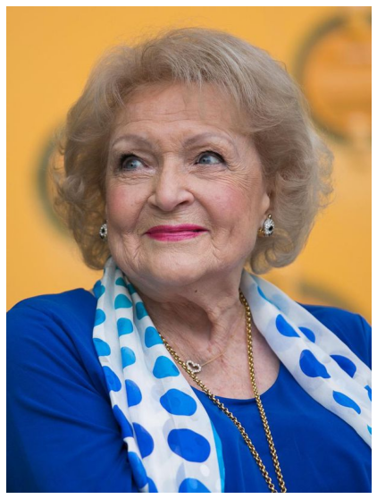

Figure 10.2: Betty White image – flipped vertically

Or the horizontal one

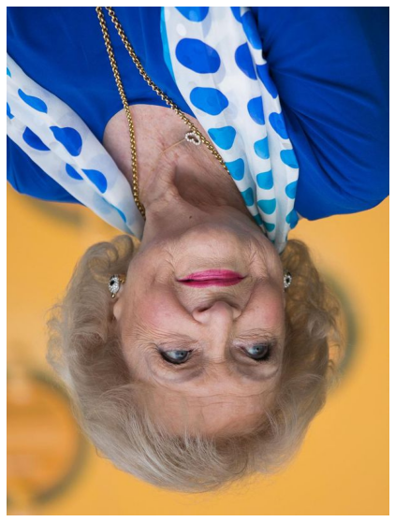

Figure 10.3: Betty White image – flipped horizontally

Rotations are fairly self-explanatory – notice the automatic padding of the image in background:

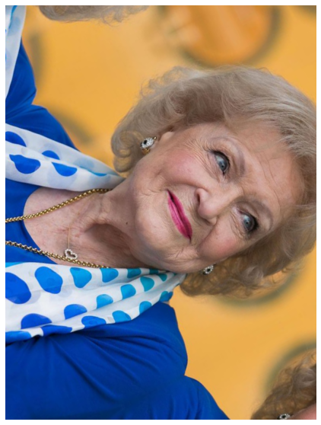

Figure 10.4: Betty White image – rotated clockwise

We can also crop an image to the region of interest:

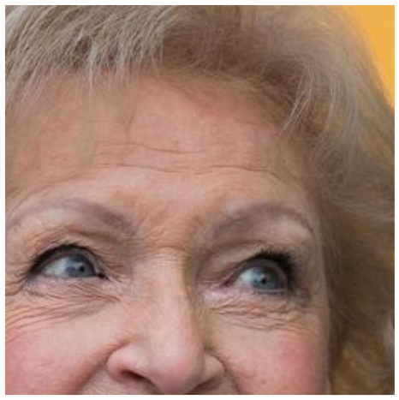

Figure 10.5: Betty White image - cropped

On a high level, we can say that augmentations can be applied in one of two manners:

* **Offline**: Those are usually applied for smaller datasets (fewer images or smaller sizes – although the definition of ‘small’ depends on the available hardware). The idea is to generate modified versions of the original images as a preprocessing step for your dataset, and then use those alongside the ‘original’ ones

**Online**: Used for bigger datasets – the augmented images are not saved on disc; the augmentations are applied in mini batches and then fed to the model

In the next few sections, we will give you an overview of two of the most common methods for augmenting your image dataset: the built-in Keras functionality and the albumentations package. There are several other options available out there (skimage, OpenCV, imgaug, Augmentor, SOLT), but we focus on the most popular ones.

The methods discussed in this chapter focus on image analysis powered by GPU; using the Tensor Processing Units (TPU) is an emerging, but still somewhat niche application. Readers interested in image augmentation in combination with TPU-powered analysis are encouraged to check out the excellent work of Chris Deotte @cdeotte:

<https://www.kaggle.com/cdeotte/triple-stratified-kfold-with-tfrecords>

Chris is a quadruple Kaggle Grandmaster, fantastic educator through the notebooks he creates and discussions he participates in – overall, a person definitely worth following for any Kaggler, irrespective of their level of experience.

We will be using data from the Cassava Leaf Disease Classification competition <https://www.kaggle.com/c/cassava-leaf-disease-classification>. As usual, we begin with the groundwork: first, loading the necessary packages:

import os

import glob

import numpy as np

import scipy as sp

import pandas as pd

import cv2

from skimage.io import imshow, imread, imsave

*# imgaug*

import imageio

import imgaug as ia

import imgaug.augmenters as iaa

*# Albumentations*

import albumentations as A

*# Keras*

*# from keras.preprocessing.image import ImageDataGenerator,array_to_img, img_to_array, load_img*

*#visualisation*

import matplotlib.pyplot as plt

import matplotlib.image as mpimg

%matplotlib inline

import seaborn as sns

from IPython.display import HTML, Image

*#warnings*

import warnings

warnings.filterwarnings("ignore")

Next, we define some helper functions that will streamline the presentation later. We need a way to load images into arrays:

def load_image(image_id):

file_path = image_id

image = imread(Image_Data_Path + file_path)

return image

We would like to display multiple images in a gallery style, so we create a function that takes as input an array containing the images, along with the desired number of columns and outputs the array reshaped into a grid with given number of columns.

def gallery(array, ncols=3):

nindex, height, width, intensity = array.shape

nrows = nindex//ncols

assert nindex == nrows*ncols

result = (array.reshape(nrows, ncols, height, width, intensity)

.swapaxes(1,2)

.reshape(height*nrows, width*ncols, intensity))

return result

With boilerplate taken care of, we can load the images for augmentation:

data_dir = '../input/cassava-leaf-disease-classification/'

Image_Data_Path = data_dir + '/train_images/'

train_data = pd.read_csv(data_dir + '/train.csv')

*# we load and store the first 10 images in memory for faster access*

train_images = train_data["image_id"][:10].apply(load_image)

Let’s load a single image so we know what our reference is:

curr_img = train_images[7]

plt.figure(figsize = (15,15))

plt.imshow(curr_img)

plt.axis('off')

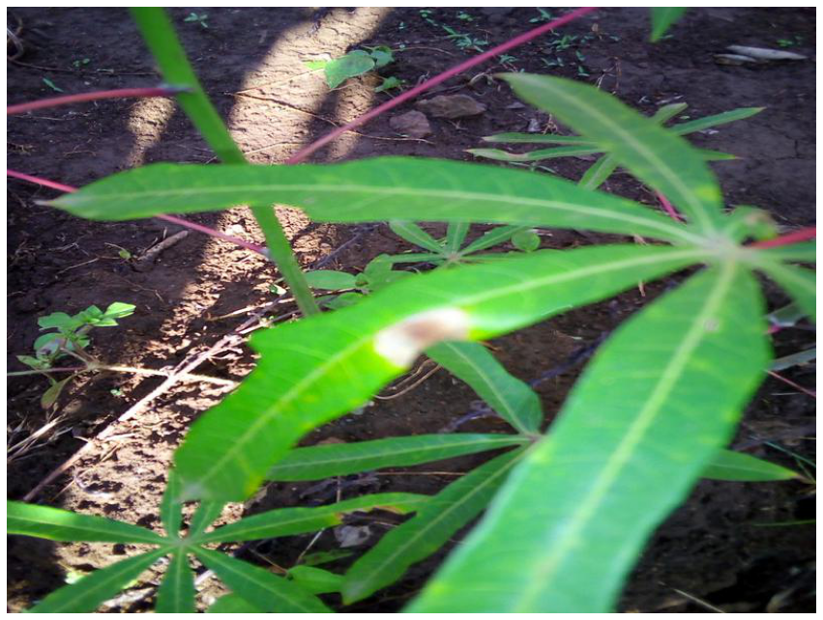

Figure 10.6: Reference image

In the following sections, we will demonstrate how to generate augmented images using both built-in Keras functionality and the albumentations library.

## Keras built-in augmentations

The Keras library has a built-in functionality for augmentations. While not as extensive as dedicated packages (albumentations, or others mentioned earlier), it has an advantage of easy integration with your code: we do not need a separate code block for defining the augmentation transformations, but can incorporate them inside ImageDataGenerator – a functionality we are likely to be using anyway.

The first Keras approach we examine is based upon the ImageDataGenerator class: as the name suggests, it can be used to generate batches of image data with real-time data augmentations.

### ImageDataGenerator approach

We begin by instantiating an object of class ImageDataGenerator in the following manner:

import tensorflow as tf

from tensorflow.keras.preprocessing.image import ImageDataGenerator,array_to_img, img_to_array, load_img

datagen = ImageDataGenerator(

rotation_range = 40,

shear_range = 0.2,

zoom_range = 0.2,

horizontal_flip = True,

brightness_range = (0.5, 1.5))

curr_img_array = img_to_array(curr_img)

curr_img_array = curr_img_array.reshape((1,) + curr_img_array.shape)

In the code above, we iterate through the images with the .flow method of the ImageDataGenerator object. The class provides three different functions to load the image dataset in memory and generate batches of augmented data:

* flow
* flow_from_directory
* flow_from_dataframe

They all achieve the same objective but differ in the way the locations of the files are specified. In our example the images are already in memory, so we can iterate using the simplest method:

i = 0

for batch **in** datagen.flow(

curr_img_array,

batch_size=1,

save_to_dir='.',

save_prefix='Augmented_image',

save_format='jpeg'):

i += 1

*# hard-coded stop - without it, the generator enters an infinite loop*

if i > 9:

break

We define the desired augmentations as arguments to ImageDataGenerator. The official documentation does not seem to address the topic, but practical results indicate that the augmentations are applied in the order in which they are defined as arguments.

In the above example, we utilize only a limited subset of possible options; for a full list, the reader is encouraged to consult the official documentation: <https://keras.io/api/preprocessing/image/>

We can examine the augmented images using the helper functions defined earlier:

aug_images = []

for img_path **in** glob.glob("*.jpeg"):

aug_images.append(mpimg.imread(img_path))

We can visualise the augmented images:

plt.figure(figsize=(20,20))

plt.axis('off')

plt.imshow(gallery(np.array(aug_images[0:9]), ncols = 3))

plt.title('Augmentation examples')

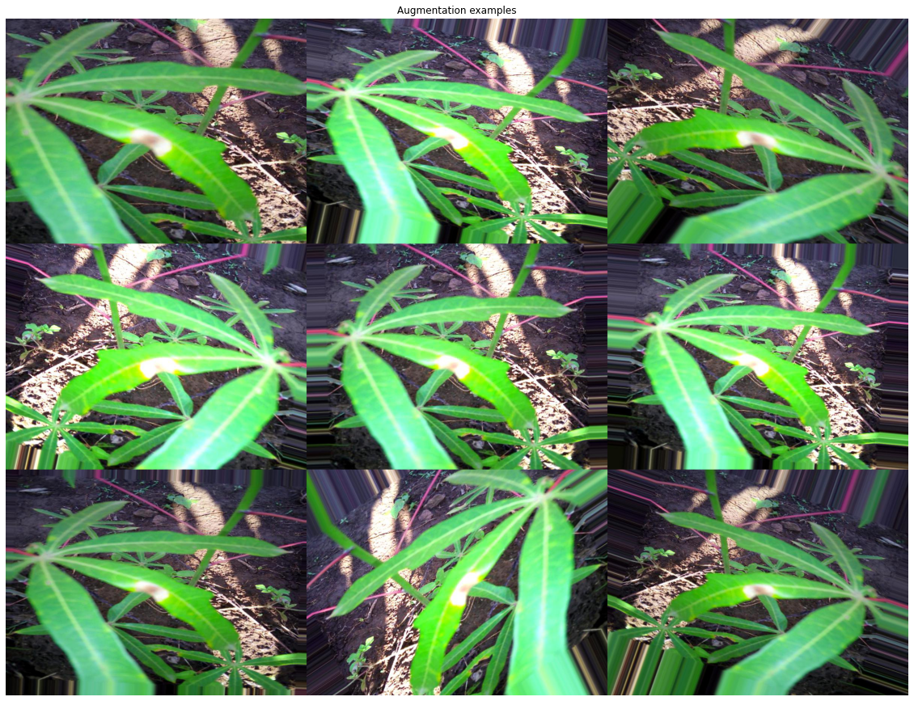

Figure 10.7: collection of augmented images

Augmentations are a very useful tool but using them efficiently does require a judgement call: first, it is obviously a good idea to visualize them to get a feeling for the impact on data. On the one hand, we want to introduce some variation in the data to increase the generalization of our model – on the other, if we change the images to radically, the input data will be less informative, and the model performance is likely to suffer. In addition, the choice of which augmentations to use can also be problem-specific, as we can see by comparing different competitions.

If you look at figure 10.1 above (the ‘reference’ image from the Cassava Leaf Disease competition), leaves on which we are supposed to identify the disease can be of different size, pointing at different angles etc. – both due to the shapes of the plants, and differences in how the images are taken. This means transformations such as vertical / horizontal flip, cropping and rotations all make sense in this context.

By contrast, we can look at a sample image from the Severstal competition <https://www.kaggle.com/c/severstal-steel-defect-detection>. In this contest, participants had localize and classify defects on a steel sheet. All the images had the same size and orientation, which means that rotations or crops would have produced unrealistic images, adding to the noise and having adverse impact on the generalization capabilities of an algorithm.

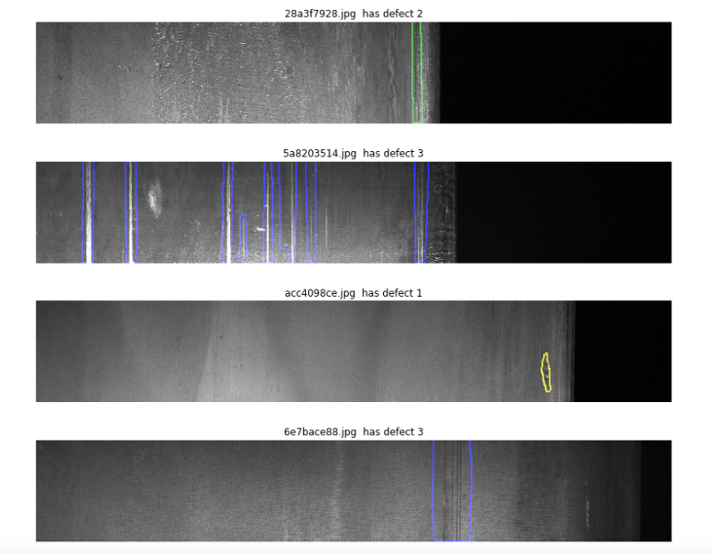

Figure 10.8: Sample image from the Severstal competition

### Preprocessing layers

An alternative approach to data augmentation as a preprocessing step in a native Keras manner is to use the preprocessing layers API. The functionality is remarkably flexible: such pipelines can be used either directly in combination with Keras models or independently in a manner similar to the ImageDataGenerator.

Below we show briefly how a preprocessing layer can be set up:

from tensorflow.keras.layers.experimental import preprocessing

from tensorflow.keras import layers

We load a pretrained model in the standard Keras manner:

pretrained_base = tf.keras.models.load_model(

'../input/cv-course-models/cv-course-models/vgg16-pretrained-base',

)

pretrained_base.trainable = False

The preprocessing layers can be used in the same way as others used inside the Sequential constructor – the only requirement is they need to be specified before others, at the beginning of our model definition

model = tf.keras.Sequential([

*# Preprocessing layers*

preprocessing.RandomFlip('horizontal'), *# flip left-to-right*

preprocessing.RandomContrast(0.5), *# contrast change by up to 50%*

*# Base moxdel*

pretrained_base,

*# model head definition*

layers.Flatten(),

layers.Dense(6, activation='relu'),

layers.Dense(1, activation='sigmoid'),

])

## Albumentations

The *albumentations* package is a fast image augmentation library which is built as a wrapper of sorts around other libraries. The full documentation can be found at: <https://albumentations.readthedocs.io/en/latest/>,

below we list the important characteristics:

* Unified API for different data types
* Support for all common computer vision tasks
* Integrates both with TensorFlow and PyTorch

For the readers interested in the history of the package – and how it originated from a Kaggle competition – a Medium post by Vladimir Iglovikov (one of the creators) is an interesting read: <https://medium.com/@iglovikov/the-birth-of-albumentations-fe38c1411cb3>

Using albumentations functionality to transform an image is straightforward: we begin by initializing the required transformations

import albumentations as A

horizontal_flip = A.HorizontalFlip(p=1)

rotate = A.ShiftScaleRotate(p=1)

gaus_noise = A.GaussNoise()

bright_contrast = A.RandomBrightnessContrast(p=1)

gamma = A.RandomGamma(p=1)

blur = A.Blur()

Apply the transformations to our reference image

img_flip = horizontal_flip(image = curr_img)

img_gaus = gaus_noise(image = curr_img)

img_rotate = rotate(image = curr_img)

img_bc = bright_contrast(image = curr_img)

img_gamma = gamma(image = curr_img)

img_blur = blur(image = curr_img)

We can access the augmented images by the ‘image’ key and visualize the results:

img_list = [img_flip['image'],img_gaus['image'], img_rotate['image'], img_bc['image'], img_gamma['image'], img_blur['image']]

plt.figure(figsize=(20,20))

plt.axis('off')

plt.imshow(gallery(np.array(img_list), ncols = 3))

plt.title('Augmentation examples')

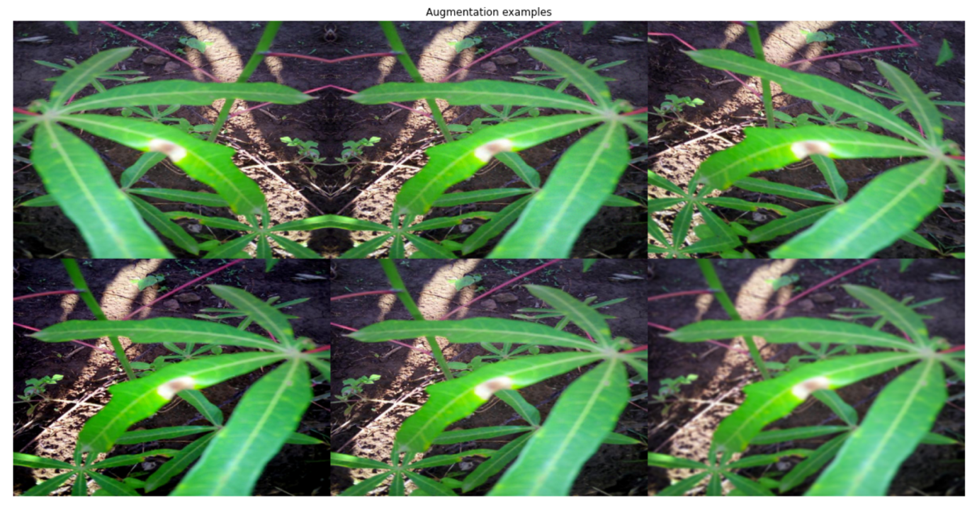

Figure 10.9: Image augmented using the albumentations library

Having discussed a crucial preprocessing step in approaching a computer vision problem, we are now in a position to apply this knowledge. This is the topic addressed in the following sections, beginning with a very common task: image classification.

# Classification

In this section, we demonstrate an end-to-end pipeline that can be used as a template for handling image classification problems. We walk through the necessary steps – from data preparation, through model setup and estimation, to results visualization; apart from being informative (and cool), this last step can also be very useful if you need to examine your code in-depth to get a better understanding of the performance. We will continue using the data from the Cassava Leaf Disease contest <https://www.kaggle.com/c/cassava-leaf-disease-classification>.

As usual, we begin with loading the necessary libraries.

import numpy as np

import pandas as pd

import matplotlib.pyplot as plt

import seaborn as sns

import datetime

from sklearn.model_selection import train_test_split

from sklearn.metrics import accuracy_score

import tensorflow as tf

from tensorflow.keras import models, layers

from tensorflow.keras.preprocessing import image

from tensorflow.keras.preprocessing.image import ImageDataGenerator

from tensorflow.keras.callbacks import ModelCheckpoint, EarlyStopping, ReduceLROnPlateau

from tensorflow.keras.applications import EfficientNetB0

from tensorflow.keras.optimizers import Adam

import os, cv2, json

from PIL import Image

It is usually a good idea to define a few helper functions; it makes for code that is easier to both read and debug. If you are approaching a general image classification problem, a good starting point can be provided by a model from the EfficientNet family, introduced in 2019 in a paper from the Google Research Brain Team: <https://arxiv.org/abs/1905.11946>. The basic idea is to balance network depth, width, and resolution to enable more efficient scaling across all dimensions and subsequently better performance. For our solution we will use the simplest member of the family – EfficientNet B0, which is a mobile-sized network with 11 million trainable parameters. The architecture diagram reproduced below is taken from the Google AI blog:

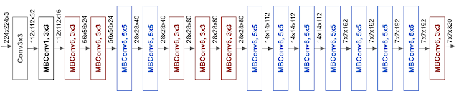

Figure 10.10: Architecture diagram for the EfficientNet B0 network

We construct our model with B0 as the basis, followed by a pooling layer for improved translation invariance and a dense activation layer (as we are working with a classification problem):

def create_model():

conv_base = EfficientNetB0(include_top = False, weights = None,

input_shape = (CFG.TARGET_SIZE, CFG.TARGET_SIZE, 3))

model = conv_base.output

model = layers.GlobalAveragePooling2D()(model)

model = layers.Dense(5, activation = "softmax")(model)

model = models.Model(conv_base.input, model)

model.compile(optimizer = Adam(lr = 0.001),

loss = "sparse_categorical_crossentropy",

metrics = ["acc"])

return model

A short remark on the parameters we pass to EfficientNetB0 function:

* Include_top parameter allows you to decide whether to include the final dense layers – as we want to use the pretrained model as a feature extractor, a default strategy would be to skip them and the define the head ourselves.
* Weights can be set to None if we want to train the model from scratch, or ‘imagenet’ if instead we prefer to utilize the ones trained on ImageNet data <https://image-net.org/>

The helper function below allows us to visualize the activation layer, so we can examine the network performance from a visual angle. This is frequently helpful in developing an intuition in a field notorious for its opacity:

def activation_layer_vis(img, activation_layer = 0, layers = 10):

layer_outputs = [layer.output for layer **in** model.layers[:layers]]

activation_model = models.Model(inputs = model.input, outputs = layer_outputs)

activations = activation_model.predict(img)

rows = int(activations[activation_layer].shape[3] / 3)

cols = int(activations[activation_layer].shape[3] / rows)

fig, axes = plt.subplots(rows, cols, figsize = (15, 15 * cols))

axes = axes.flatten()

for i, ax **in** zip(range(activations[activation_layer].shape[3]), axes):

ax.matshow(activations[activation_layer][0, :, :, i], cmap = 'viridis')

ax.axis('off')

plt.tight_layout()

plt.show()

We generate the activations by creating predictions for a given model based on a 'restricted’ model, i.e. using the entire architecture up until the penultimate layer – this is the code block up to the *activations* variable. The rest of the function ensures we show the right layout of activations, corresponding to the shape of the filter in the appropriate convolution layer.

Next, we process the labels and set up the validation scheme; there is no special structure in the data (time dimension, overlap across classes), we can use a simple random split. For a refresher on more elaborate validation schemes, the reader is referred to the Chapter “Designing a good validation scheme”:

train_labels = pd.read_csv(os.path.join(CFG.WORK_DIR, "train.csv"))

STEPS_PER_EPOCH = len(train_labels)*0.8 / CFG.BATCH_SIZE

VALIDATION_STEPS = len(train_labels)*0.2 / CFG.BATCH_SIZE

We are now able to set up the data generators, which are necessary for our TF-based algorithm to loop through the image data. First, we instantiate two ImageDataGenerator objects – this is when we incorporate the image augmentations. For the purpose of this demonstration, we go with the Keras built-in ones. After that, we create the generator using a flow_from_dataframe() method, which is used to generate batches of tensor image data with real-time data augmentation.

train_labels.label = train_labels.label.astype('str')

train_datagen = ImageDataGenerator(

validation_split = 0.2, preprocessing_function = None,

rotation_range = 45, zoom_range = 0.2,

horizontal_flip = True, vertical_flip = True,

fill_mode = 'nearest', shear_range = 0.1,

height_shift_range = 0.1, width_shift_range = 0.1)

train_generator = train_datagen.flow_from_dataframe(

train_labels,

directory = os.path.join(CFG.WORK_DIR, "train_images"),

subset = "training",

x_col = "image_id",y_col = "label",

target_size = (CFG.TARGET_SIZE, CFG.TARGET_SIZE),

batch_size = CFG.BATCH_SIZE,

class_mode = "sparse")

validation_datagen = ImageDataGenerator(

validation_split = 0.2)

validation_generator = validation_datagen.flow_from_dataframe(

train_labels,

directory = os.path.join(CFG.WORK_DIR, "train_images"),

subset = "validation",

x_col = "image_id",y_col = "label",

target_size = (CFG.TARGET_SIZE, CFG.TARGET_SIZE),

batch_size = CFG.BATCH_SIZE, class_mode = "sparse")

With the data structures specified, we can create the model:

model = create_model()

model.summary()

Model: "functional_1"

__________________________________________________________________________________________________

Layer (type) Output Shape Param # Connected to

==================================================================================================

input_1 (InputLayer) [(None, 512, 512, 3) 0

__________________________________________________________________________________________________

rescaling (Rescaling) (None, 512, 512, 3) 0 input_

Once our model is created, we can quickly examine a summary – this is mostly useful for sanity checks, because unless you have a photographic memory, chances are you are not going to remember the layer composition batches of a sophisticated model like EfnetB0. In practice, you can use the summary to check if the dimensions of output filters are correct or if the parameter counts (trainable on non-trainable) are in line with expectations. For the sake of compactness, we only demonstrate first few lines of the output – inspecting the architecture diagram for B0 (shown earlier) gives an idea of how long the complete output would be.

With the above steps taken care of, we can proceed to fitting the model. In this step, we can also very conveniently define callbacks: the first one is model checkpoint.

model_save = ModelCheckpoint('./EffNetB0_512_8_best_weights.h5',

save_best_only = True,

save_weights_only = True,

monitor = 'val_loss',

mode = 'min', verbose = 1)

Typically, we want to re-use a fitted model:

* we can preserve the best set of model weights by setting save_best_only = True
* we reduce the size of the model by only keeping the weights, instead of the complete set of optimizer state etc.
* we decide on which model is the optimal by locating a minimum for validation loss

early_stop = EarlyStopping(monitor = 'val_loss', min_delta = 0.001,

patience = 5, mode = 'min', verbose = 1,

restore_best_weights = True)

Next, we see one of the popular methods for preventing overfitting, early stopping: we monitor the performance of the model on the holdout set and stop the algorithm if the metric stops improving for a given number of epochs, in this case 5.

reduce_lr = ReduceLROnPlateau(monitor = 'val_loss', factor = 0.3,

patience = 2, min_delta = 0.001,

mode = 'min', verbose = 1)

Finally, models often benefit from reducing the learning rate once learning stagnates; the phenomenon is related – the ReduceLROnPlateau callback monitors the loss on the holdout set and if no improvement is seen for a patience number of epochs, the learning rate is reduced, in this case by a factor of 0.3.

history = model.fit(

train_generator,

steps_per_epoch = STEPS_PER_EPOCH,

epochs = CFG.EPOCHS,

validation_data = validation_generator,

validation_steps = VALIDATION_STEPS,

callbacks = [model_save, early_stop, reduce_lr]

)

Explaining briefly the two parameters not encountered before:

* training generator yields steps_per_epoch batches per training epoch
* when the epoch is finished, the validation generator produces validation_steps batches

An example output after calling model.fit() is given below:

Epoch 00001: val_loss improved from inf to 0.57514, saving model to ./EffNetB0_512_8_best_weights.h5

Once a model is fitted, we can examine the activations on a sample image using the helper function we wrote at the start. While not necessary for a successful model execution, it can help determine what sort of features is our model extracting before applying the classification layer at the top.

activation_layer_vis(img_tensor, 0)

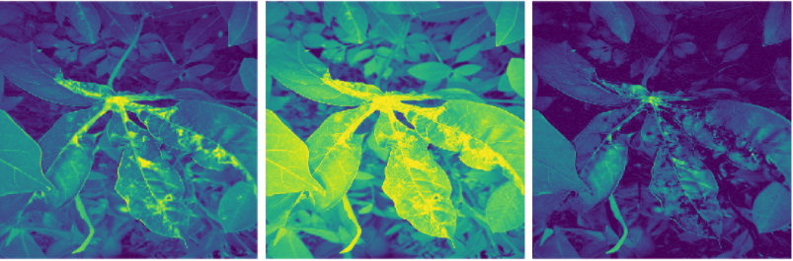

Figure 10.11: sample activations from a fitted model

We can generate the predictions with model.predict():

ss = pd.read_csv(os.path.join(CFG.WORK_DIR, "sample_submission.csv"))

preds = []

for image_id **in** ss.image_id:

image = Image.open(os.path.join(CFG.WORK_DIR, "test_images", image_id))

image = image.resize((CFG.TARGET_SIZE, CFG.TARGET_SIZE))

image = np.expand_dims(image, axis = 0)

preds.append(np.argmax(model.predict(image)))

ss['label'] = preds

We build the predictions by iterating through the list of images – for each of them, we reshape the image to the required dimensions and pick the channel with the strongest signal (the model predicts class probabilities, of which we pick the largest one with argmax). The final predictions are class numbers, in line with the metric utilized in the comp.

In this section, we demonstrated a minimal end-to-end pipeline for image classification. Numerous improvements are of course possible (more augmentations, bigger architecture, callbacks customization), but the basic underlying template should provide the reader with a good starting point going forward.

We move now to a second popular problem in computer vision: object detection.

# Object detection

Object detection is a computer vision / image processing task, where we need to identify instances of semantic objects of a certain class in image or video. In classification problems discussed in the previous section, we simply need to assign a class to each image, whereas in object detection tasks we want to draw a bounding box around an object of interest to locate it within an image.

In this section, we will use data from the Global Wheat Detection competition <https://www.kaggle.com/c/global-wheat-detection>. In this contest, participants had to detect wheat heads – spikes atop plant containing grain; detections in plant images are used to estimate size and density of wheat heads across crop varieties.

We will demonstrate an example pipeline for solving this problem. As usual, we begin by importing the necessary packages:

import numpy as np

import pandas as pd

import tensorflow as tf

import os

import matplotlib.pyplot as plt

from PIL import Image, ImageDraw, ImageEnhance

import albumentations as albu

from tqdm.notebook import tqdm

Next, we need some helper functions: the raw data provided in the competition, each bounding box was an array of length 4 formatted as a string. The helper function below groups the bounding boxes by image id and places the bounding boxes as numpy arrays next to each image id. Subsequently, all the bounding boxes can be easily retrieved by image id.

def group_boxes(group):

boundaries = group['bbox'].str.split(',', expand=True)

boundaries[0] = boundaries[0].str.slice(start=1)

boundaries[3] = boundaries[3].str.slice(stop=-1)

return boundaries.values.astype(float)

We need some helper functions to visualize the images. The first two functions take an image id and the corresponding bounding boxes and return the bounding boxes drawn onto the image, while the last one is a wrapper allowing us to loop over multiple images.

def draw_bbox(draw, bbox):

x, y, width, height = bbox

draw.rectangle([x, y, x + width, y + height], width=2, outline='red')

def draw_bboxes(image_id, bboxes, source='train'):

image = Image.open('../input/global-wheat-detection/' + source +'/' + image_id + ".jpg")

image = image.resize((CFG.image_size,CFG.image_size))

draw = ImageDraw.Draw(image)

for bbox **in** bboxes:

draw_bbox(draw, bbox)

return np.asarray(image)

def show_images(image_ids, bboxes, source='train'):

pixels = []

for image_id **in** image_ids:

pixels.append(

draw_bboxes(image_id, bboxes[image_id], source)

)

num_of_images = len(image_ids)

fig, axes = plt.subplots(

1,

num_of_images,

figsize=(5 * num_of_images, 5 * num_of_images)

)

for i, image_pixels **in** enumerate(pixels):

axes[i].imshow(image_pixels)

Next, we need a function to load the images - for the sake of speed, we rescale the images, so we can iterate faster through the versions.

def load_image(image_id):

image = Image.open('../input/global-wheat-detection/train/' + image_id + ".jpg")

image = image.resize((CFG.img_size, CFG.img_size))

return np.asarray(image)

Keras implementation of the YoloV3-type architecture - taken from the excellent kernel by Matt Bastow <https://www.kaggle.com/mattbast>. YoloV3 is a a real-time object detection algorithm that identifies specific objects in videos, live feeds, or images. YOLO uses features learned by a deep convolutional neural network to detect an object. Versions 1-3 of YOLO were created by Joseph Redmon and Ali Farhadi. The specific changes introduced in v3 are discussed in the paper by the authors: <https://arxiv.org/abs/1804.02767>

The model begins with a convolutional layer with 32 filters which doubles in size in the next layer. The filters are then halved in size before doubling every layer up to 128 layers. The filters are then halved again while a larger stride reduces the size of the input image. This pattern of doubling and halving filter sizes continues with a few repeated blocks until we reach a size of 1024. ResNet skip layers are added for stabilization purposes - they also reduce the chance for vanishing gradients <https://en.wikipedia.org/wiki/Vanishing_gradient_problem>.

def create_model():

x_input = tf.keras.Input(shape=(CFG.image,256,3))

x = tf.keras.layers.Conv2D(32, (3, 3), strides=(1, 1), padding='same')(x_input)

x = tf.keras.layers.BatchNormalization()(x)

x = tf.keras.layers.LeakyReLU(alpha=0.1)(x)

*########## block 1 ##########*

x = tf.keras.layers.Conv2D(64, (3, 3), strides=(1, 1), padding='same')(x)

x = tf.keras.layers.BatchNormalization()(x)

x = tf.keras.layers.LeakyReLU(alpha=0.1)(x)

x_shortcut = x

for i **in** range(2):

x = tf.keras.layers.Conv2D(32, (3, 3), strides=(1, 1), padding='same')(x)

x = tf.keras.layers.BatchNormalization()(x)

x = tf.keras.layers.LeakyReLU(alpha=0.1)(x)

x = tf.keras.layers.Conv2D(64, (3, 3), strides=(1, 1), padding='same')(x)

x = tf.keras.layers.BatchNormalization()(x)

x = tf.keras.layers.LeakyReLU(alpha=0.1)(x)

x = tf.keras.layers.Add()([x_shortcut, x])

x = tf.keras.layers.LeakyReLU(alpha=0.1)(x)

x_shortcut = x

*########## block 2 ##########*

x = tf.keras.layers.Conv2D(128, (3, 3), strides=(1, 1), padding='same')(x)

x = tf.keras.layers.BatchNormalization()(x)

x = tf.keras.layers.LeakyReLU(alpha=0.1)(x)

x_shortcut = x

for i **in** range(2):

x = tf.keras.layers.Conv2D(64, (3, 3), strides=(1, 1), padding='same')(x)

x = tf.keras.layers.BatchNormalization()(x)

x = tf.keras.layers.LeakyReLU(alpha=0.1)(x)

x = tf.keras.layers.Conv2D(128, (3, 3), strides=(1, 1), padding='same')(x)

x = tf.keras.layers.BatchNormalization()(x)

x = tf.keras.layers.LeakyReLU(alpha=0.1)(x)

x = tf.keras.layers.Add()([x_shortcut, x])

x = tf.keras.layers.LeakyReLU(alpha=0.1)(x)

x_shortcut = x

*########## block 3 ##########*

x = tf.keras.layers.Conv2D(256, (3, 3), strides=(2, 2), padding='same')(x)

x = tf.keras.layers.BatchNormalization()(x)

x = tf.keras.layers.LeakyReLU(alpha=0.1)(x)

x_shortcut = x

for i **in** range(8):

x = tf.keras.layers.Conv2D(128, (3, 3), strides=(1, 1), padding='same')(x)

x = tf.keras.layers.BatchNormalization()(x)

x = tf.keras.layers.LeakyReLU(alpha=0.1)(x)

x = tf.keras.layers.Conv2D(256, (3, 3), strides=(1, 1), padding='same')(x)

x = tf.keras.layers.BatchNormalization()(x)

x = tf.keras.layers.LeakyReLU(alpha=0.1)(x)

x = tf.keras.layers.Add()([x_shortcut, x])

x = tf.keras.layers.LeakyReLU(alpha=0.1)(x)

x_shortcut = x

*########## block 4 ##########*

x = tf.keras.layers.Conv2D(512, (3, 3), strides=(2, 2), padding='same')(x)

x = tf.keras.layers.BatchNormalization()(x)

x = tf.keras.layers.LeakyReLU(alpha=0.1)(x)

x_shortcut = x

for i **in** range(8):

x = tf.keras.layers.Conv2D(256, (3, 3), strides=(1, 1), padding='same')(x)

x = tf.keras.layers.BatchNormalization()(x)

x = tf.keras.layers.LeakyReLU(alpha=0.1)(x)

x = tf.keras.layers.Conv2D(512, (3, 3), strides=(1, 1), padding='same')(x)

x = tf.keras.layers.BatchNormalization()(x)

x = tf.keras.layers.LeakyReLU(alpha=0.1)(x)

x = tf.keras.layers.Add()([x_shortcut, x])

x = tf.keras.layers.LeakyReLU(alpha=0.1)(x)

x_shortcut = x

*########## block 5 ##########*

x = tf.keras.layers.Conv2D(1024, (3, 3), strides=(2, 2), padding='same')(x)

x = tf.keras.layers.BatchNormalization()(x)

x = tf.keras.layers.LeakyReLU(alpha=0.1)(x)

x_shortcut = x

for i **in** range(4):

x = tf.keras.layers.Conv2D(512, (3, 3), strides=(1, 1), padding='same')(x)

x = tf.keras.layers.BatchNormalization()(x)

x = tf.keras.layers.LeakyReLU(alpha=0.1)(x)

x = tf.keras.layers.Conv2D(1024, (3, 3), strides=(1, 1), padding='same')(x)

x = tf.keras.layers.BatchNormalization()(x)

x = tf.keras.layers.LeakyReLU(alpha=0.1)(x)

x = tf.keras.layers.Add()([x_shortcut, x])

x = tf.keras.layers.LeakyReLU(alpha=0.1)(x)

x_shortcut = x

*########## output layers ##########*

x = tf.keras.layers.Conv2D(512, (3, 3), strides=(1, 1), padding='same')(x)

x = tf.keras.layers.BatchNormalization()(x)

x = tf.keras.layers.LeakyReLU(alpha=0.1)(x)

x = tf.keras.layers.Conv2D(256, (3, 3), strides=(1, 1), padding='same')(x)

x = tf.keras.layers.BatchNormalization()(x)

x = tf.keras.layers.LeakyReLU(alpha=0.1)(x)

x = tf.keras.layers.Conv2D(128, (3, 3), strides=(1, 1), padding='same')(x)

x = tf.keras.layers.BatchNormalization()(x)

x = tf.keras.layers.LeakyReLU(alpha=0.1)(x)

predictions = tf.keras.layers.Conv2D(10, (1, 1), strides=(1, 1), activation='sigmoid')(x)

model = tf.keras.Model(inputs=x_input, outputs=predictions)

return model

We start our solution by examining the input data:

labels = pd.read_csv('../input/global-wheat-detection/train.csv')

labels.head()

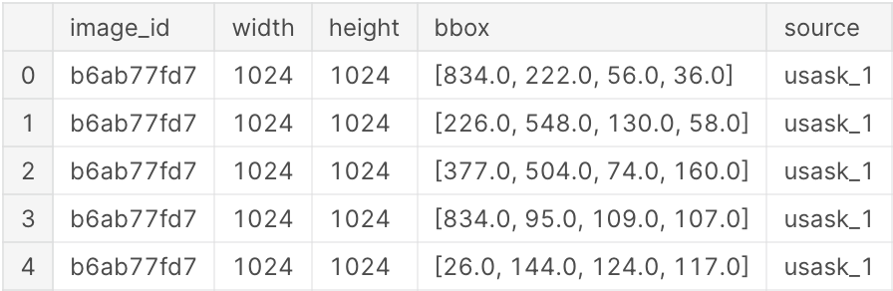

Figure 10.12: sample of the competition data

labels.source.value_counts()

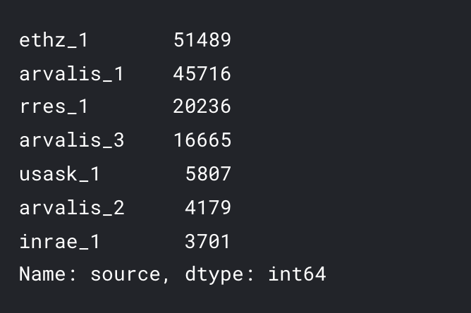

The competition page stated the following: "You will use more than 3,000 images from Europe (France, UK, Switzerland) and North America (Canada). The test data includes about 1,000 images from Australia, Japan, and China". This means using a random split for training / validation would introduce leakage, so we need to split on area of origin - the source column. We will use Switzerland as a holdout region.

labels_train = labels.loc[labels.source != 'ethz_1'].copy()

labels_valid = labels.loc[labels.source == 'ethz_1'].copy()

We reformat the bounding boxes using the helper function defined above

labels_train = labels_train.groupby('image_id').apply(group_boxes)

labels_valid = labels_valid.groupby('image_id').apply(group_boxes)

labels_train.head()

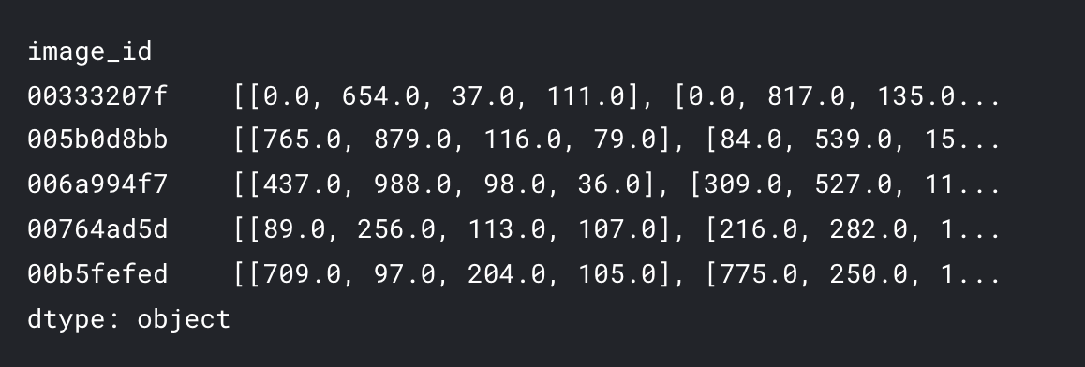

We proceed to prepare the images / labels structures for the training and validation parts:

train_image_ids = labels_train.index.values

val_image_ids = labels_valid.index.values

train_pixels = {}

train_labels = {}

for image_id **in** tqdm(train_image_ids):

train_pixels[image_id] = load_image(image_id)

train_labels[image_id] = labels_train[image_id].copy() / 4

val_pixels = {}

val_labels = {}

for image_id **in** tqdm(val_image_ids):

val_pixels[image_id] = load_image(image_id)

val_labels[image_id] = labels_valid[image_id].copy() / 4

For the task at hand, we build a slightly customized data generator to incorporate the required preprocessing in a convenient manner. The instantiated object of this custom class is passed to the fit generator method. The class methods need to:

* define the size of the dataset. Keras needs this to work out how long an epoch is
* shuffle the dataset
* get an image and augment it to add variety to the dataset. This includes amending bounding boxes when a head of wheat has changed in the image
* reshape the bounding boxes to a label grid
* length: used to determine the number of images in the dataset
* on_epoch_end is called at the start of training, as well as at the end to get the indices of images of interest

class **DataGenerator**(tf.keras.utils.Sequence):

def __init__(self, image_ids, image_pixels, labels=None, batch_size=1, shuffle=False, augment=False):

self.image_ids = image_ids

self.image_pixels = image_pixels

self.labels = labels

self.batch_size = batch_size

self.shuffle = shuffle

self.augment = augment

self.on_epoch_end()

self.image_grid = self.form_image_grid()

def form_image_grid(self):

image_grid = np.zeros((32, 32, 4))

*# x, y, width, height*

cell = [0, 0, 256 / 32, 256 / 32]

for i **in** range(0, 32):

for j **in** range(0, 32):

image_grid[i,j] = cell

cell[0] = cell[0] + cell[2]

cell[0] = 0

cell[1] = cell[1] + cell[3]

return image_grid

def __len__(self):

return int(np.floor(len(self.image_ids) / self.batch_size))

def on_epoch_end(self):

self.indexes = np.arange(len(self.image_ids))

if self.shuffle == True:

np.random.shuffle(self.indexes)

DataGenerator.__len__ = __len__

DataGenerator.on_epoch_end = on_epoch_end

As usual, it is useful to visualise a few sample images – it can give us a feel for the kind of augmentations that might be useful for our problem:

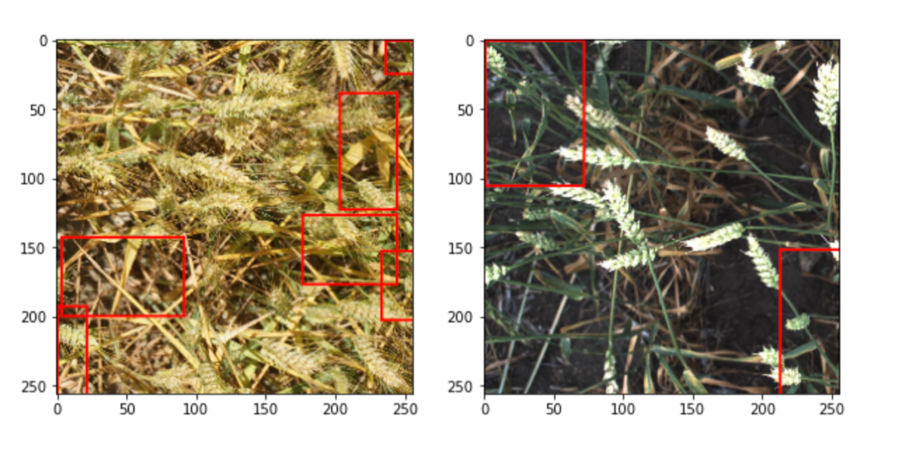

Figure 10.12: Sample image visualizations

The dataset provided by the competition organizers was rather moderate sized (less than four thousand images), so it is important to augment the it to a significant degree:

* **random sized crop:** The model needs to be able to detect a wheat head regardless of how close or far away the head is to the camera; the crop method will takes a portion of the image and zooms in to create a new image with larger wheat heads.
* **flip amd rotate**: The wheat heads can point in any direction. To create more examples of wheat heads pointing in different directions, the image will randomly be flipped both horizontally and vertically or rotated.
* **hue saturation and brightness:** these are various methods that will alter the lighting of the image which will help to create different lighting scenarios. This helps as the test pictures are from various countries each with their own lighting levels.
* **noise:** Some wheat heads aren't quite in focus. Adding some noise to the images helps to catch these wheat heads while also forcing the model to learn more abstract wheat head shapes.
* **cutout**: randomly remove small squares of pixels in the image. This prevents the model simply memorizing certain wheat heads and instead forces it to learn the patterns that represent a wheat head.
* **clahe:** In many images the wheat heads are a similar colour to the grass in the background making it tricky for the model to differentiate between them. CLAHE helps to exemplify the colour difference between the two.
* **grey scale:** By converting all images to grey scale the model is forced to ignore these tints making it much more effective at identifying wheat heads regardless of tint.

DataGenerator.train_augmentations = albu.Compose([

albu.RandomSizedCrop(

min_max_height=(200, 200),

height=256,

width=256,

p=0.8

),

albu.OneOf([

albu.Flip(),

albu.RandomRotate90(),

], p=1),

albu.OneOf([

albu.HueSaturationValue(),

albu.RandomBrightnessContrast()

], p=1),

albu.OneOf([

albu.GaussNoise(),

albu.GlassBlur(),

albu.ISONoise(),

albu.MultiplicativeNoise(),

], p=0.5),

albu.Cutout(

num_holes=8,

max_h_size=16,

max_w_size=16,

fill_value=0,

p=0.5

),

albu.CLAHE(p=1),

albu.ToGray(p=1),

],

bbox_params={'format': 'coco', 'label_fields': ['labels']})

DataGenerator.val_augmentations = albu.Compose([

albu.CLAHE(p=1),

albu.ToGray(p=1),

])

The two functions defined below load an image and its corresponding bounding boxes, taking image id as argument; in addition, augmentations are performed, and bounding boxes resized.

def __getitem__(self, index):

indexes = self.indexes[index * self.batch_size:(index + 1) * self.batch_size]

batch_ids = [self.image_ids[i] for i **in** indexes]

X, y = self.__data_generation(batch_ids)

return X, y

def __data_generation(self, batch_ids):

X, y = [], []

*# Generate data*

for i, image_id **in** enumerate(batch_ids):

pixels = self.image_pixels[image_id]

bboxes = self.labels[image_id]

if self.augment:

pixels, bboxes = self.augment_image(pixels, bboxes)

else:

pixels = self.contrast_image(pixels)

bboxes = self.form_label_grid(bboxes)

X.append(pixels)

y.append(bboxes)

return np.array(X), np.array(y)

def augment_image(self, pixels, bboxes):

bbox_labels = np.ones(len(bboxes))

aug_result = self.train_augmentations(image=pixels, bboxes=bboxes, labels=bbox_labels)

bboxes = self.form_label_grid(aug_result['bboxes'])

return np.array(aug_result['image']) / 255, bboxes

def contrast_image(self, pixels):

aug_result = self.val_augmentations(image=pixels)

return np.array(aug_result['image']) / 255

DataGenerator.__getitem__ = __getitem__

DataGenerator.__data_generation = __data_generation

DataGenerator.augment_image = augment_image

DataGenerator.contrast_image = contrast_image

An important point worth mentioning there are different formats for annotations – describing coordinates of a rectangle can be achieved with different (mathematically equivalent) manners. Most common types are coco, voc-pascal and yolo. The differences between them are clear from the figure below:

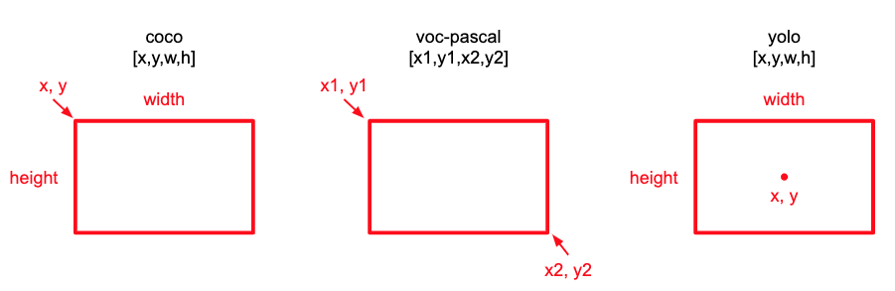

Figure 10.13: Annotation formats for bounding boxes

Since our architecture is based on YoloV3, we will be using the Yolo format in the model. One more part we need to define is the grid structure: yolo detects objects by placing a grid over an image and checking for the presence of an object of interest (wheat head in our case) in any of the cells. The bounding boxes are reshaped to be offset within the relevant cells of the image and the (x,y,w,h) parameters are scaled to the unit interval.

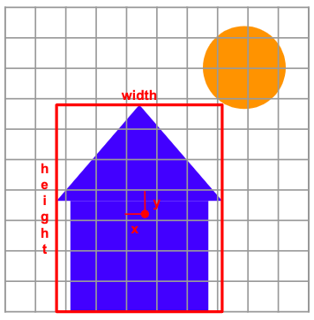

Figure 10.14: Yolo annotation positioning

Each bounding box gets a confidence score where a value of 1 tells us that a wheat head is present in the cell and a value of 0 tells us that no object is present. So a cell with an object present could contain a value like this: [1, 0.5, 0.5, 0.2, 0.2] telling us that there is an object present (due to the confidence score of 1, the centre of the bounding box is exactly in the middle of the cell and the box is 20% of the images total width and height.

def form_label_grid(self, bboxes):

label_grid = np.zeros((32, 32, 10))

for i **in** range(0, 32):

for j **in** range(0, 32):

cell = self.image_grid[i,j]

label_grid[i,j] = self.rect_intersect(cell, bboxes)

return label_grid

def rect_intersect(self, cell, bboxes):

cell_x, cell_y, cell_width, cell_height = cell

cell_x_max = cell_x + cell_width

cell_y_max = cell_y + cell_height

anchor_one = np.array([0, 0, 0, 0, 0])

anchor_two = np.array([0, 0, 0, 0, 0])

*# check all boxes*

for bbox **in** bboxes:

box_x, box_y, box_width, box_height = bbox

box_x_centre = box_x + (box_width / 2)

box_y_centre = box_y + (box_height / 2)

if(box_x_centre >= cell_x **and** box_x_centre < cell_x_max **and** box_y_centre >= cell_y **and** box_y_centre < cell_y_max):

if anchor_one[0] == 0:

anchor_one = self.yolo_shape(

[box_x, box_y, box_width, box_height],

[cell_x, cell_y, cell_width, cell_height]

)

elif anchor_two[0] == 0:

anchor_two = self.yolo_shape(

[box_x, box_y, box_width, box_height],

[cell_x, cell_y, cell_width, cell_height]

)

else:

break

return np.concatenate((anchor_one, anchor_two), axis=None)

def yolo_shape(self, box, cell):

box_x, box_y, box_width, box_height = box

cell_x, cell_y, cell_width, cell_height = cell

*# top left x,y to centre x,y*

box_x = box_x + (box_width / 2)

box_y = box_y + (box_height / 2)

*# offset bbox x,y to cell x,y*

box_x = (box_x - cell_x) / cell_width

box_y = (box_y - cell_y) / cell_height

*# bbox width,height relative to cell width,height*

box_width = box_width / 256

box_height = box_height / 256

return [1, box_x, box_y, box_width, box_height]

DataGenerator.form_label_grid = form_label_grid

DataGenerator.rect_intersect = rect_intersect

DataGenerator.yolo_shape = yolo_shape

Finally, we can combine the building blocks defined above into the training and validation generators:

train_generator = DataGenerator(

train_image_ids,

train_pixels,

train_labels,

batch_size=6,

shuffle=True,

augment=True

)

val_generator = DataGenerator(

val_image_ids,

val_pixels,

val_labels,

batch_size=10,

shuffle=False,

augment=False

)

image_grid = train_generator.image_grid

We instantiate the model:

model = create_model()

The original Yolo paper referenced above addresses an issue with the model: the label grid is likely to contain in its grid more cells without objects than with objects. As a result, the model performance will be driven by reducing the error associated with the former than with the latter – so the detection will miss out on wheat heads. The suggestion of the authors is to weigh the cells containing bounding boxes higher than the empty ones. The custom loss function below implements this idea: it combines the confidence score associated with the box (to decide if the cell is empty) and the size and position of the bounding boxes.

def get_mask(y_true):

anchor_one_mask = tf.where(

y_true[:,:,:,0] == 0,

0.5,

5.0

)

anchor_two_mask = tf.where(

y_true[:,:,:,5] == 0,

0.5,

5.0

)

bboxes_mask = tf.concat(

[anchor_one_mask,anchor_two_mask],

axis=0

)

return bboxes_mask

def custom_loss(y_true, y_pred):

binary_crossentropy = prob_loss = tf.keras.losses.BinaryCrossentropy(

reduction=tf.keras.losses.Reduction.SUM_OVER_BATCH_SIZE

)

prob_loss = binary_crossentropy(

tf.concat([y_true[:,:,:,0], y_true[:,:,:,5]], axis=0),

tf.concat([y_pred[:,:,:,0], y_pred[:,:,:,5]], axis=0)

)

xy_loss = tf.keras.losses.MSE(

tf.concat([y_true[:,:,:,1:3], y_true[:,:,:,6:8]], axis=0),

tf.concat([y_pred[:,:,:,1:3], y_pred[:,:,:,6:8]], axis=0)

)

wh_loss = tf.keras.losses.MSE(

tf.concat([y_true[:,:,:,3:5], y_true[:,:,:,8:10]], axis=0),

tf.concat([y_pred[:,:,:,3:5], y_pred[:,:,:,8:10]], axis=0)

)

bboxes_mask = get_mask(y_true)

xy_loss = xy_loss * bboxes_mask

wh_loss = wh_loss * bboxes_mask

return prob_loss + xy_loss + wh_loss

We use our custom loss at model compilation stage:

optimiser = tf.keras.optimizers.Adam(learning_rate=0.0001)

model.compile(

optimizer=optimiser,

*loss=custom_loss*

)

In order to prevent overfitting, we add callbacks: early stopping and learning rate reduction schema; both are achieved using standard Keras functionality

callbacks = [

tf.keras.callbacks.ReduceLROnPlateau(monitor='loss', patience=2, verbose=1),

tf.keras.callbacks.EarlyStopping(monitor='loss', patience=5, verbose=1, restore_best_weights=True),

]

After the elaborate setup that was necessary, we are finally ready to train the model:

history = model.fit_generator(

train_generator,

validation_data=val_generator,

epochs = CFG.nof_epochs,

callbacks=callbacks

)

After the training is completed, we can inspect the performance:

print('Epochs: ' + str(len(history.history['loss'])))

print('Final training loss: ' + str( np.round(history.history['loss'][-1],4) ))

print('Final validation loss: ' + str( np.round( history.history['val_loss'][-1], 4) ))

Epochs: 10

Final training loss: 0.0495

Final validation loss: 0.0769

The validation loss is higher than training, which indicates some degree of overfitting taking place. We can examine the phenomenon in more detail:

fig, ax = plt.subplots(1, 2, figsize=(15, 5))

ax[0].set_title('Training Loss')

ax[0].plot(history.history['loss'])

ax[1].set_title('Validation Loss')

ax[1].plot(history.history['val_loss'])

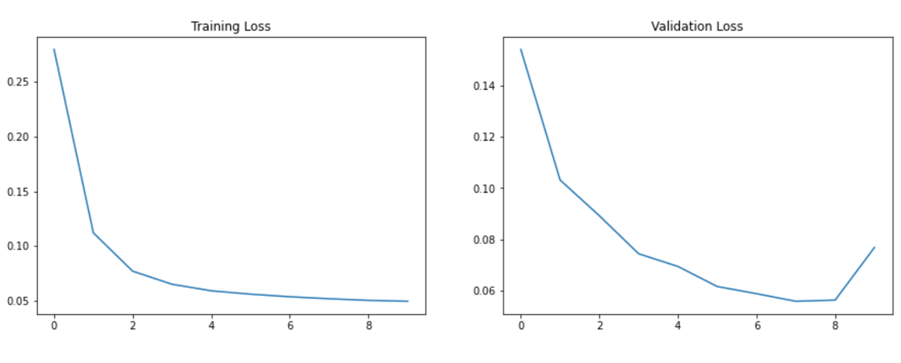

Figure 10.15: Training vs validation loss

Before we can visualize the predicted bounding boxes (or submit them to the competition in the required format), we need to reformat the results. The first function transforms the boxes in steps:

* return the scale of the boxes from 0-1 to 0-256
* shift the coordinates from the centre of the box to the top left corner
* convert the parametrization from width and height to x_max, y_max

def prediction_to_bbox(bboxes, image_grid):

bboxes = bboxes.copy()

im_width = (image_grid[:,:,2] * 32)

im_height = (image_grid[:,:,3] * 32)

*# descale x,y*

bboxes[:,:,1] = (bboxes[:,:,1] * image_grid[:,:,2]) + image_grid[:,:,0]

bboxes[:,:,2] = (bboxes[:,:,2] * image_grid[:,:,3]) + image_grid[:,:,1]

bboxes[:,:,6] = (bboxes[:,:,6] * image_grid[:,:,2]) + image_grid[:,:,0]

bboxes[:,:,7] = (bboxes[:,:,7] * image_grid[:,:,3]) + image_grid[:,:,1]

*# descale width,height*

bboxes[:,:,3] = bboxes[:,:,3] * im_width

bboxes[:,:,4] = bboxes[:,:,4] * im_height

bboxes[:,:,8] = bboxes[:,:,8] * im_width

bboxes[:,:,9] = bboxes[:,:,9] * im_height

*# centre x,y to top left x,y*

bboxes[:,:,1] = bboxes[:,:,1] - (bboxes[:,:,3] / 2)

bboxes[:,:,2] = bboxes[:,:,2] - (bboxes[:,:,4] / 2)

bboxes[:,:,6] = bboxes[:,:,6] - (bboxes[:,:,8] / 2)

bboxes[:,:,7] = bboxes[:,:,7] - (bboxes[:,:,9] / 2)

*# width,heigth to x_max,y_max*

bboxes[:,:,3] = bboxes[:,:,1] + bboxes[:,:,3]

bboxes[:,:,4] = bboxes[:,:,2] + bboxes[:,:,4]

bboxes[:,:,8] = bboxes[:,:,6] + bboxes[:,:,8]

bboxes[:,:,9] = bboxes[:,:,7] + bboxes[:,:,9]

return bboxes

Next step involves the removal of boxes with low confidence score, as well as those overlapping with another box:

def non_max_suppression(predictions, top_n):

probabilities = np.concatenate((predictions[:,:,0].flatten(), predictions[:,:,5].flatten()), axis=None)

first_anchors = predictions[:,:,1:5].reshape((32*32, 4))

second_anchors = predictions[:,:,6:10].reshape((32*32, 4))

bboxes = np.concatenate(

(first_anchors,second_anchors),

axis=0

)

bboxes = switch_x_y(bboxes)

bboxes, probabilities = select_top(probabilities, bboxes, top_n=top_n)

bboxes = switch_x_y(bboxes)

return bboxes

def switch_x_y(bboxes):

x1 = bboxes[:,0].copy()

y1 = bboxes[:,1].copy()

x2 = bboxes[:,2].copy()

y2 = bboxes[:,3].copy()

bboxes[:,0] = y1

bboxes[:,1] = x1

bboxes[:,2] = y2

bboxes[:,3] = x2

return bboxes

def select_top(probabilities, boxes, top_n=10):

top_indices = tf.image.non_max_suppression(

boxes = boxes,

scores = probabilities,

max_output_size = top_n,

iou_threshold = 0.3,

score_threshold = 0.3

)

top_indices = top_indices.numpy()

return boxes[top_indices], probabilities[top_indices]

We can combine the preprocessing functionality defined above:

def process_predictions(predictions, image_ids, image_grid):

bboxes = {}

for i, image_id **in** enumerate(image_ids):

predictions[i] = prediction_to_bbox(predictions[i], image_grid)

bboxes[image_id] = non_max_suppression(predictions[i], top_n=100)

*# back to coco shape*

bboxes[image_id][:,2:4] = bboxes[image_id][:,2:4] - bboxes[image_id][:,0:2]

return bboxes

We can visualize some of the results by plotting predictions generated on the validation set:

val_predictions = model.predict(val_generator)

val_predictions = process_predictions(val_predictions, val_image_ids, image_grid)

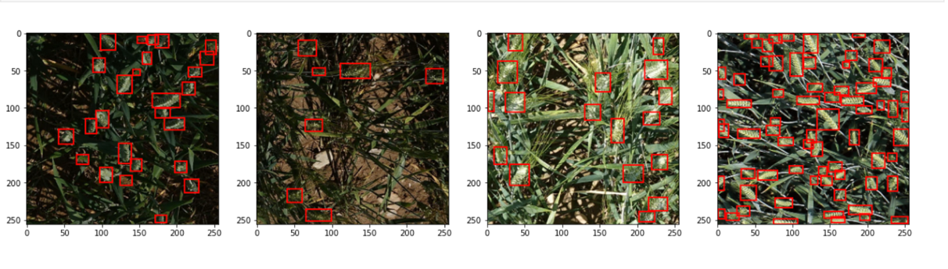

Figure 10.16: Selected prediction results on the validation set

In this section we introduced a simple pipeline for approaching the problem of object detection: we demonstrated how to handle annotations in different formats, how to customize a model for a specific task, train it and evaluate the results. On the basis of the knowledge thus acquired, a reader should be able to start working with object detection problems. We now move to the third popular class of computer vision tasks: semantic segmentation.

# Semantic segmentation

The easiest way to think about segmentation is that it classifies each pixel in an image, assigning it to a corresponding class; combined, those pixels form areas of interest, such as regions with disease on an organ in medical images. By contrast, object detection (discussed in the previous section) classifies patches of an image into different object classes and creates bounding boxes around them.

We will demonstrate the modeling approach using data from the Sartorius competition: <https://www.kaggle.com/c/sartorius-cell-instance-segmentation> . In this one, the participants were tasked presented with a set of contrast microscopy images to train models for instance segmentation of neuronal cells. Our solution will be built around Detectron2: <https://github.com/facebookresearch/detectron2>

Detectron2 is a library created by Facebook AI Research, supporting multiple detection and segmentation algorithms; it is a successor to the original Detectron library <https://github.com/facebookresearch/Detectron/> and the Mask R-CNN project <https://github.com/facebookresearch/maskrcnn-benchmark/>.

We begin by installing the extra packages:

* pycocotools, which we will need to format the annotations <https://github.com/cocodataset/cocoapi/tree/master/PythonAPI/pycocotools>
* Detectron2 – our workhorse in this task <https://github.com/facebookresearch/detectron2>

!pip install pycocotools

!pip install 'git+https://github.com/facebookresearch/detectron2.git'

Before we can train our model, we need a bit of preparation: the annotations need to be converted from the run-length encoding (RLE) format provided by the organizers to the COCO format (required as input for Detectron2). The basic idea behind RLE is saving space: instead of an exhaustive list of indices for your segmentation, you submit a starting position and a run length.

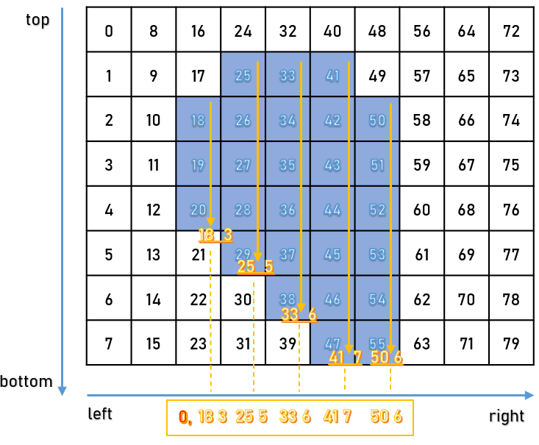

Figure 10.17: Visual representation of RLE

Microsoft Common Objects in Context (COCO) format is a specific json structure dictating how labels and metadata are saved for an image dataset. Below, we demonstrate how to convert RLE to COCO and combine it with a k-fold validation split (so we get the required train / validation pair of .json files for each fold).

import skimage.io as io

import matplotlib.pyplot as plt

from pathlib import Path

from PIL import Image

import pandas as pd

import numpy as np

from tqdm.notebook import tqdm

import json,itertools

from sklearn.model_selection import GroupKFold

*# config*

class **CFG**:

data_path = '../input/sartorius-cell-instance-segmentation/'

nfolds = 5

We need three functions to go from RLE to COCO: first, convert from RLE to a binary mask:

*# From https://www.kaggle.com/stainsby/fast-tested-rle*

def rle_decode(mask_rle, shape):

*'''*

*mask_rle: run-length as string formated (start length)*

*shape: (height,width) of array to return*

*Returns numpy array, 1 - mask, 0 - background*

*'''*

s = mask_rle.split()

starts, lengths = [np.asarray(x, dtype=int) for x **in** (s[0:][::2], s[1:][::2])]

starts -= 1

ends = starts + lengths

img = np.zeros(shape[0]*shape[1], dtype=np.uint8)

for lo, hi **in** zip(starts, ends):

img[lo:hi] = 1

return img.reshape(shape) *# Needed to align to RLE direction*

The second one converts a binary mask to RLE:

*# From https://newbedev.com/encode-numpy-array-using-uncompressed-rle-for-coco-dataset*

def binary_mask_to_rle(binary_mask):

rle = {'counts': [], 'size': list(binary_mask.shape)}

counts = rle.get('counts')

for i, (value, elements) **in** enumerate(itertools.groupby(binary_mask.ravel(order='F'))):

if i == 0 **and** value == 1:

counts.append(0)

counts.append(len(list(elements)))

return rle

Finally, we combine the two in order to produce the COCO output:

def coco_structure(train_df):

cat_ids = {name:id+1 for id, name **in** enumerate(train_df.cell_type.unique())}

cats =[{'name':name, 'id':id} for name,id **in** cat_ids.items()]

images = [{'id':id, 'width':row.width, 'height':row.height, 'file_name':f'train/**{**id**}**.png'} for id,row **in** train_df.groupby('id').agg('first').iterrows()]

annotations=[]

for idx, row **in** tqdm(train_df.iterrows()):

mk = rle_decode(row.annotation, (row.height, row.width))

ys, xs = np.where(mk)

x1, x2 = min(xs), max(xs)

y1, y2 = min(ys), max(ys)

enc =binary_mask_to_rle(mk)

seg = {

'segmentation':enc,

'bbox': [int(x1), int(y1), int(x2-x1+1), int(y2-y1+1)],

'area': int(np.sum(mk)),

'image_id':row.id,

'category_id':cat_ids[row.cell_type],

'iscrowd':0,

'id':idx

}

annotations.append(seg)

return {'categories':cats, 'images':images,'annotations':annotations}

We split our data into non-overlapping folds

train_df = pd.read_csv(CFG.data_path + 'train.csv')

gkf = GroupKFold(n_splits = CFG.nfolds)

train_df["fold"] = -1

y = train_df.width.values

for f, (t_, v_) **in** enumerate(gkf.split(X=train_df, y=y, groups=train_df.id.values)):

train_df.loc[v_, "fold"] = f

fold_id = train_df.fold.copy()

We can now loop over the folds: the reason the loop had to be executed in pieces was the size limit of the Kaggle environment; a complete set of .json files (5 folds, 2 files – training / validation – for each took more than 20GB in total). Such practical considerations are worth keeping in mind when running code in a Kaggle notebook – although for such ‘preparatory’ work you can of course produce the results elsewhere, and upload them as Kaggle datasets afterwards.

all_ids = train_df.id.unique()

*# for fold in range(CFG.nfolds):*

for fold **in** range(1,2):

train_sample = train_df.loc[fold_id != fold]

root = coco_structure(train_sample)

with open('annotations_train_f'+str(fold)+'.json', 'w', encoding='utf-8') as f:

json.dump(root, f, ensure_ascii=True, indent=4)

valid_sample = train_df.loc[fold_id == fold]

print('fold ' + str(fold) + ': produced')

for fold **in** range(1,2):

train_sample = train_df.loc[fold_id == fold]

root = coco_structure(train_sample)

with open('annotations_valid_f'+str(fold)+'.json', 'w', encoding='utf-8') as f:

json.dump(root, f, ensure_ascii=True, indent=4)

valid_sample = train_df.loc[fold_id == fold]

print('fold ' + str(fold) + ': produced')

With the splits produces, we can move towards training a Detectron2 model for our dataset. As usual, we start with loading the necessary packages:

from datetime import datetime

import os

import pandas as pd

import numpy as np

import pycocotools.mask as mask_util

import detectron2

from pathlib import Path

import random, cv2, os

import matplotlib.pyplot as plt

*# import some common detectron2 utilities*

from detectron2 import model_zoo

from detectron2.engine import DefaultPredictor, DefaultTrainer

from detectron2.config import get_cfg

from detectron2.utils.visualizer import Visualizer, ColorMode

from detectron2.data import MetadataCatalog, DatasetCatalog

from detectron2.data.datasets import register_coco_instances

from detectron2.utils.logger import setup_logger

from detectron2.evaluation.evaluator import DatasetEvaluator

from detectron2.engine import BestCheckpointer

from detectron2.checkpoint import DetectionCheckpointer

setup_logger()

import torch

While the number of imports from Detectron2 can seem intimidating at first contact, their function will become clear as we progress with the task definition.

class **CFG**:

wfold = 4

data_folder = './input/'

anno_folder = './input/annotations/'

model_arch = 'mask_rcnn_R_50_FPN_3x.yaml'

nof_iters = 1000

seed = 45

One point worth mentioning here is the iterations parameter (*nof_iters* above): usually model training is parametrized in terms of number of epochs, i.e. complete passes through the training data. Detectron2 is engineered differently: one iteration refers to one mini-batch and different mini-batch sizes are used in different parts of the model.

In order to ensure the results are reproducible, we fix random seeds used by different components of the model:

def seed_everything(seed):

random.seed(seed)

os.environ['PYTHONHASHSEED'] = str(seed)

np.random.seed(seed)

torch.manual_seed(seed)

torch.cuda.manual_seed(seed)

torch.backends.cudnn.deterministic = True

seed_everything(CFG.seed)

The competition metric was the mean average precision at different intersection over union (IoU) thresholds. The IoU of a proposed set of object pixels and a set of true object pixels is calculated as:

𝐼𝑜𝑈(𝐴,𝐵)=𝐴∩𝐵 / 𝐴∪𝐵

The metric sweeps over a range of IoU thresholds, at each point calculating an average precision value. The threshold values range from 0.5 to 0.95.

At each threshold value 𝑡t, a precision value is calculated based on the number of true positives (TP), false negatives (FN), and false positives (FP) resulting from comparing the predicted object to all ground truth objects. Lastly, the score returned by the competition metric is the mean taken over the individual average precisions of each image in the test dataset.

Below, we define the functions necessary to calculate the metric and use it directly inside the model as the objective function:

*# Taken from https://www.kaggle.com/theoviel/competition-metric-map-iou*

def precision_at(threshold, iou):

matches = iou > threshold

true_positives = np.sum(matches, axis=1) == 1 *# Correct objects*

false_positives = np.sum(matches, axis=0) == 0 *# Missed objects*

false_negatives = np.sum(matches, axis=1) == 0 *# Extra objects*

return np.sum(true_positives), np.sum(false_positives), np.sum(false_negatives)

def score(pred, targ):

pred_masks = pred['instances'].pred_masks.cpu().numpy()

enc_preds = [mask_util.encode(np.asarray(p, order='F')) for p **in** pred_masks]

enc_targs = list(map(lambda x:x['segmentation'], targ))

ious = mask_util.iou(enc_preds, enc_targs, [0]*len(enc_targs))

prec = []

for t **in** np.arange(0.5, 1.0, 0.05):

tp, fp, fn = precision_at(t, ious)

p = tp / (tp + fp + fn)

prec.append(p)

return np.mean(prec)

With the metric defined, we can use it in the model:

class **MAPIOUEvaluator**(DatasetEvaluator):

def __init__(self, dataset_name):

dataset_dicts = DatasetCatalog.get(dataset_name)

self.annotations_cache = {item['image_id']:item['annotations'] for item **in** dataset_dicts}

def reset(self):

self.scores = []

def process(self, inputs, outputs):

for inp, out **in** zip(inputs, outputs):

if len(out['instances']) == 0:

self.scores.append(0)

else:

targ = self.annotations_cache[inp['image_id']]

self.scores.append(score(out, targ))

def evaluate(self):

return {"MaP IoU": np.mean(self.scores)}

This gives us the basis for creating a Trainer object which is the workhorse of our solution built around Detectron2:

class **Trainer**(DefaultTrainer):

@classmethod

def build_evaluator(cls, cfg, dataset_name, output_folder=None):

return MAPIOUEvaluator(dataset_name)

def build_hooks(self):

*# copy of cfg*

cfg = self.cfg.clone()

*# build the original model hooks*

hooks = super().build_hooks()

*# add the best checkpointer hook*

hooks.insert(-1, BestCheckpointer(cfg.TEST.EVAL_PERIOD,

DetectionCheckpointer(self.model, cfg.OUTPUT_DIR),

"MaP IoU",

"max",

))

return hooks

We proceed to load the training / validation data in Detectron2 style:

dataDir=Path(CFG.data_folder)

register_coco_instances('sartorius_train',{}, CFG.anno_folder + 'annotations_train_f'+str(CFG.wfold)+'.json', dataDir)

register_coco_instances('sartorius_val',{}, CFG.anno_folder + 'annotations_valid_f'+str(CFG.wfold)+'.json', dataDir)

metadata = MetadataCatalog.get('sartorius_train')

train_ds = DatasetCatalog.get('sartorius_train')

Before we instantiate a Detectron2 model, we need to take care of configuring it – most of the values can be (at least in a first pass) left at default values; if you decide to tinker a bit more, start with BATCH_SIZE_PER_IMAGE (for increased generalization performance) and SCORE_THRESH_TEST (to limit false negatives).

cfg = get_cfg()

cfg.INPUT.MASK_FORMAT='bitmask'

cfg.merge_from_file(model_zoo.get_config_file('COCO-InstanceSegmentation/' + CFG.model_arch))

cfg.DATASETS.TRAIN = ("sartorius_train",)

cfg.DATASETS.TEST = ("sartorius_val",)

cfg.DATALOADER.NUM_WORKERS = 2

cfg.MODEL.WEIGHTS = model_zoo.get_checkpoint_url('COCO-InstanceSegmentation/' + CFG.model_arch)

cfg.SOLVER.IMS_PER_BATCH = 2

cfg.SOLVER.BASE_LR = 0.001

cfg.SOLVER.MAX_ITER = CFG.nof_iters

cfg.SOLVER.STEPS = []

cfg.MODEL.ROI_HEADS.BATCH_SIZE_PER_IMAGE = 512

cfg.MODEL.ROI_HEADS.NUM_CLASSES = 3

cfg.MODEL.ROI_HEADS.SCORE_THRESH_TEST = .4

cfg.TEST.EVAL_PERIOD = len(DatasetCatalog.get('sartorius_train')) // cfg.SOLVER.IMS_PER_BATCH

Training a model is straightforward – and rich in information about the progress of the procedure:

os.makedirs(cfg.OUTPUT_DIR, exist_ok=True)

trainer = Trainer(cfg)

trainer.resume_or_load(resume=False)

trainer.train()

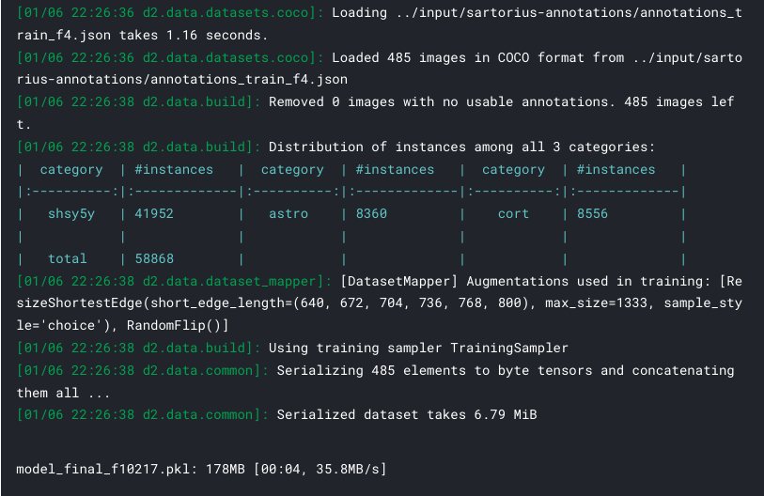

Figure 10.18: Training output from Detectron2

Once the model is trained, we can use the weights obtained for the best one to conduct inference and prepare a submission. We start by adding new parameters that allow us to regularize the prediction: set confidence thresholds and minimal mask sizes

THRESHOLDS = [.18, .35, .58]

MIN_PIXELS = [75, 150, 75]

We need a helper function for encoding a single mask into RLE format:

def rle_encode(img):

*'''*

*img: numpy array, 1 - mask, 0 - background*

*Returns run length as string formated*

*'''*

pixels = img.flatten()

pixels = np.concatenate([[0], pixels, [0]])

runs = np.where(pixels[1:] != pixels[:-1])[0] + 1

runs[1::2] -= runs[::2]

return ' '.join(str(x) for x **in** runs)

The main function for producing all masks per image, filtering out the dubious ones (with confidence scores below THRESHOLDS) with small areas (containing fewer pixels than MIN_PIXELS):

def get_masks(fn, predictor):

im = cv2.imread(str(fn))

pred = predictor(im)

pred_class = torch.mode(pred['instances'].pred_classes)[0]

take = pred['instances'].scores >= THRESHOLDS[pred_class]

pred_masks = pred['instances'].pred_masks[take]

pred_masks = pred_masks.cpu().numpy()

res = []

used = np.zeros(im.shape[:2], dtype=int)

for mask **in** pred_masks:

mask = mask * (1-used)

if mask.sum() >= MIN_PIXELS[pred_class]: *# skip predictions with small area*

used += mask

res.append(rle_encode(mask))

return res

We prepare the lists where image ids and masks will be stored:

dataDir=Path(CFG.data_folder)

ids, masks=[],[]

test_names = (dataDir/'test').ls()

Read the weights for a model trained previously (in the contest it was necessary to use an inference kernel – loading model as from a separate dataset – to meet the execution time requirements):

cfg = get_cfg()

cfg.merge_from_file(model_zoo.get_config_file("COCO-InstanceSegmentation/"+CFG.arch+".yaml"))

cfg.INPUT.MASK_FORMAT='bitmask'

cfg.MODEL.ROI_HEADS.NUM_CLASSES = 3

cfg.MODEL.WEIGHTS = CFG.model_folder + 'model_best_f'+str(CFG.wfold)+'.pth'

cfg.MODEL.ROI_HEADS.SCORE_THRESH_TEST = 0.5

cfg.TEST.DETECTIONS_PER_IMAGE = 1000

predictor = DefaultPredictor(cfg)

We can visualize some of the predictions:

encoded_masks = get_masks(test_names[0], predictor)

_, axs = plt.subplots(1,2, figsize=(40,15))

axs[1].imshow(cv2.imread(str(test_names[0])))

for enc **in** encoded_masks:

dec = rle_decode(enc)

axs[0].imshow(np.ma.masked_where(dec==0, dec))

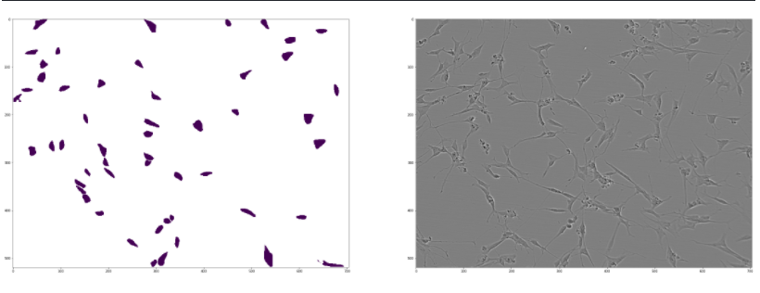

Figure 10.19: Visualising sample prediction from Detectron2 alongside source image

With the helper functions defined above, producing the masks in RLE format for submission is straightforward:

for fn **in** test_names:

encoded_masks = get_masks(fn, predictor)

for enc **in** encoded_masks:

ids.append(fn.stem)

masks.append(enc)

pd.DataFrame({'id':ids, 'predicted':masks}).to_csv('submission.csv', index=False)

pd.read_csv('submission.csv').head()

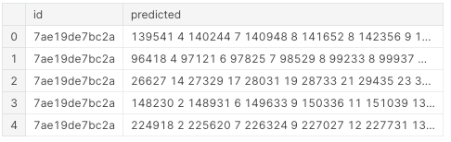

Figure 10.20: Formatted submission from a trained Detectron2 model

The above pipeline demonstrates how to set up a semantic segmentation model and train it. We have used a small number of iterations, but in order to achieve competitive results longer training is necessary.

Computations on a scale described in this section routinely exceed the time limit of 9h, imposed in Code competitions (https://www.kaggle.com/docs/competitions). A typical workaround is to conduct a training first (e.g. in Google Colab, GCP or locally), and then upload the model weights to a second kernel (the "inference kernel").

# Summary

In this chapter we gave an overview of the most important topics related to computer vision from a Kaggle competition angle. We introduced augmentations – and important class of techniques used for extending the generalization capabilities of an algorithm and followed by demonstrating end-to-end pipelines for three of the most frequent problems: image classification, object detection and semantic segmentation.

In the next chapter we switch our attention on natural language processing (NLP) – another extremely broad and popular category of problems.